**STOCK MARKET CHARTING MILESTONE 3**

Emp id: 765623

Github link:

https://github.com/Madhupreethajkp/Milestone3_Rest

IPOPlanned Details:

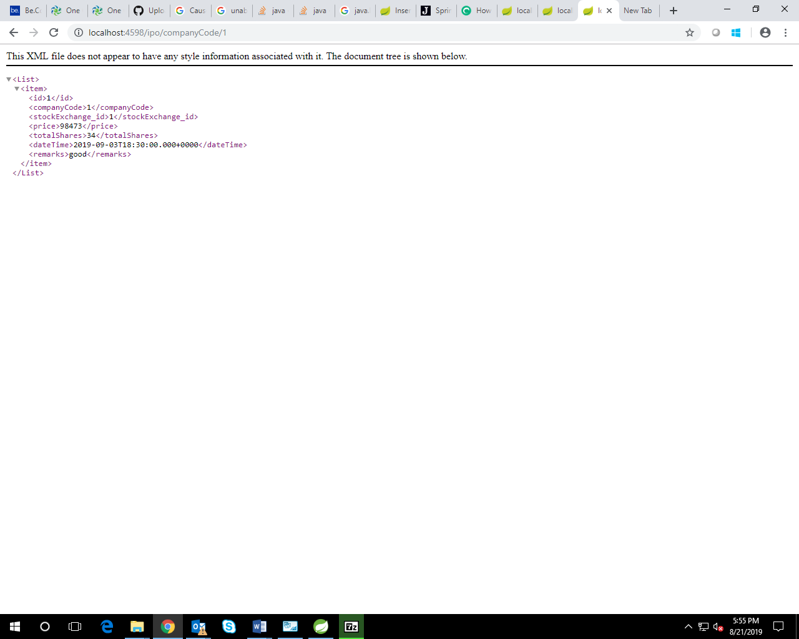

Company Details:

